Mobile Application To Secure Tenure (MAST) Project – BURKINA FASO  
Training Manual (VillaGe Level)- Spatial Data CaPture

## Overview

The proposed mapping process follows a data flow that is structured, but iterative if necessary. The use of mobile technologies seeks to improve the process of adjudication and mapping by engaging citizens in the process of land administration. CFV agents will interview citizens and collect spatial and attribute information as part of the rural adjudication process. The approach outlined in this document are focused on capturing spatial data as part adjudication process.

|  |  |
| --- | --- |
|  | Figure 1 depicts the proposed deployment of MAST in Burkina Faso. The highlighted areas depicts that area concerned with collecting spatial and attribute information.  The village mapping team will consist of CFV agents that are designated to collect information for the registration of the APFR. The data collected will be validated by SFR agents in the field and at Land Office at the commune level.  The mapping and data collection is concerned with capturing two types of information using the mobile phone: 1) spatial information or map of the parcel boundary, and 2) information about the property and the persons who occupy the property.  The following sections of the document will provide an overview of the MAST mobile application, specifically the mapping tools that facilitate the capture of spatial information. |
| **Figure 1: Proposed MAST deployment in Boudry Commune, Burkina Faso** | |

## Landing Page

|  |  |
| --- | --- |
|  | For data collection purposes, the SFR and CFV agents will utilize the following main functions that are available on the MAST Data Capture Application landing page or homepage. These are:   * Vue du Plan * Saisir les donnees * Revoir les donnees * Synchronizer les donnees |

## Vue du PLan (Map Viewer)

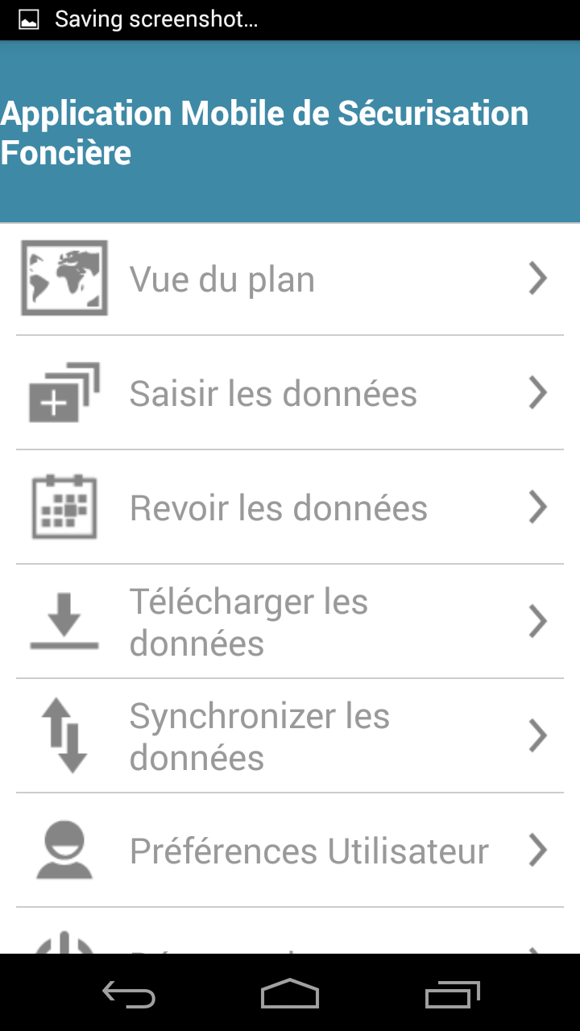

This functionality will allow users to view spatial data. It allows for the display of the following data layers:

* Base map (Satellite data downloaded from server)
* Google base map
* Collected parcel data (if collected by the user)
* Raster and Vector data that has been compiled for the project

The mapping viewing tool also provides a variety of tools and facilities.

|  |  |
| --- | --- |
| Signets et fonctions  Obtenir les coordonnees du lieu  Gestionnaire de couche  GPS | * **Signets et fonctions** It allows the user to access several tools, such as add bookmarks, go to bookmarks, measurement tools, and information tools * **Obtenir les coordonnees du lieu** is available on top of ‘Vue de plan” form. It allows users to capture the coordinates of the location by tapping the screen. * **GPS** – is a functionality that facilitates user to navigate the map to the current location using GPS tools that are available in the phone or through an external GPS device. * **Gestionnaire de couche** - is available on left top of Vue de Plan form. It provides the user control of spatial layers. |

|  |  |
| --- | --- |
|  | **Gestionnaire de couche**  Gestionnaire de couche tool is available on left top of Vue de Plan form. It provides the user control of spatial layers.  Several spatial layers are available in MAST. These include:   * Carte Satellite – which is streamed from google maps through a API; * Saisir les elements – which are the data that have been captured by the user; * BF\_Ratser – which is a raster file created from imagery of external sources; * BF\_Vector - which is a vector file created from imagery of external sources. |
| Visualser les signets  Ajouter un signet  Info plan  Mesurer | **Signets et fonctions**  It allows the user to access several tools, such as add bookmarks, go to bookmarks, measurement tools, and information tools   * Mesurer – this feature allows opens a dialogue box that provides the user several options for measurement:   + Calculer la distance   + Calculer la superfice   + Mesurer la superficie du polygone * Info plan - This functionality facilitates user to View the attribute details of any spatial feature which is already created on map * Ajouter un signet - Bookmarks tool facilitate users to save a particular area of interest of map canvas to save for future reference. * Visualser les signets - This functionality facilitates user to navigate a selected bookmark. |

## Saisir les donnees (Data Capture)

This functionality is used to Capture New Spatial Unit or Mapping Unit.

User will click on ‘Capture Data’ button available in Map Viewer.



This functionality provides multiple tools to capture spatial data on map. Polygon features can be created by ‘manual drawing’ or via GPS. User can capture a polygon manually or by using GPS by entering location coordinates.

### Choose un appareil

|  |  |
| --- | --- |
|  | User taps the option ‘Choose un Appareil’.  This allows user to select an external GPS tool, which is paired with the MAST mobile application. |

### Saisir les Donnees (Capture Data)

|  |  |
| --- | --- |
|  | ‘Saisir le polygone’ option facilitate user to capture polygon on map. User can capture a polygon manually by clicking on map or using GPS.  User taps the option ‘Capture Polygon’.  The “dessiner le polygon” is used to capture a spatial unit through on-screen digitizing, while the “saisir le polygone par GPS” is used to capture the polygon using internal GPS tools or external GPS tools. |

#### Dessiner le polygone

|  |  |
| --- | --- |
| Save  Undo | To draw a polygon, the user first clicks on the map and the first vertex will be created. The user can zoom-in and zoom-out to select the location of the second, third or more locations on map until the polygon is closed. Markers will be placed on clicked locations and polygon will be created.  The user can then click on “Save option” available on top right to save the feature, or can use the ‘undo’ button to undo the vertices.  Once the polygon is saved, the Capture Attribute’ form will be displayed. For the capture of attributes, please refer to < enter name of village training part 2 –attributes>. |

#### saisir le polygone par GPS

|  |  |
| --- | --- |
| Accuracy and number of satellites  ‘Plot Point by GPS’  Undo  Delete  Save | This facilitates the user to ‘Saisir le polygone par GPS’. The user clicks on the ‘Saisir le polygone par GPS’ option available and presented with a map view. Several important tools are available to the user:   * Save * Delete * Undo * Plot Point by GPS * Accuracy and Number of Satellites   The user must click on the ‘Plot point by GPS’ icon and a marker will be placed on current location using GPS. The user will move with the device to the other second location and click on the ‘Plot point by GPS’ and the Marker on second location will be placed on current location using GPS. Move the device to third or more locations and click on ‘Plot point by GPS’ and the Marker will be placed on current location using GPS and polygon will be created.  It is very important for the user to be aware of the accuracy reading available on the ‘Capture Data Screen’. The user will capture points for accuracy reading of 3meters or less.  Once all of the points are captured for the desired polygon, the user can click on the Save option available on top right. Polygon placed on map will be saved and ‘Capture Attribute’ form will be displayed |

## Revoir les donnees (review Data)

Once data is captured, users will report back to technical support staff for analysis and evaluation of information captured in mobile device.



At this stage, CFV members will work with SFR agents and field coordinators to verify the information that is captured in the field. At this stage, the data can be modified or deleted before it is marked as ‘complete’ for future syncing at established internet “hot spot”.

It is important to note that, at this stage, lands may be required to be resurveyed, and CFV agents may have to return to the areas that have already been surveyed with mobile devices to verify the details, etc. and fill in gaps, if any.

|  |  |
| --- | --- |
|  | In the review data from, the data is held in “ebauche”, marked as ”termine” and/or is marked as “synchronize”.  These three stages are important for reviewing data and moving data to the Land Rights Data Management Infrastructure application which will provides tools to ingest, manage and store data of land rights information:   * Ebauche – spatial and attribute data can be reviewed by user before marking data as complete for synchronization to the Land Rights Data Management infrastructure; * Termine – once data is marked as completed it can be synchronized to the Land Rights Data Management infrastructure via a web services; and * Synchronize - This functionality facilitates users to submit completed and verified data to back-end cloud server |
|  | In Ebauche stage, a user can select from the popupmenu that is anchored to the view. This will open a dialogue box that allows the following functionality: “modifier les donnees spatiales”, “modifier les attributs”, “supprimer la saisie” or “marquer comme termine”.   * Modifier les donnees spatiales – this functionality allows the user to to perform editing on spatial data. * Modifier les attributs – This facilitates the user to Modifer les attributs of a spatial unit. * Supprimer la saisie – this functionality allows users to Supprimer la saisie, which includes the spatial unit along with all of its attribute data. * Marquer comme termine - This functionality facilitate user to mark a parcel complete, once a parcel is completed. It can be synchronized. |

|  |  |
| --- | --- |
| Modifier les donnees spatiales | Once the “Modifier les donnees spatiales” function is selected, the user will navigate to the map and zoom to the corresponding feature. The feature will be highlighted and the nodes will be visible.  A communication message will appear indicating “appui long sur les punaises pour activar le mode edition et faire glisser pour changer”  User will navigate to the map feature and select a node/vertices by long pressing the node/vertices, which will allow the user to edit the feature. The editing can be done for all nodes of the features. After the editing is completed the user will clink the save button.  The application will save the spatial edits. |

|  |  |  |
| --- | --- | --- |
| Modifier les attributes |  | User will navigate to the ‘synthese des donnees collectés’ that will display the summarized details of survey.  At the bottom of the page there will be a button for the ‘modifier les attributs. Once the user clicks on the modifier les attributs button, the user will automatically go through the editing of attributes.  The collection and editing of attributes is described < enter name of village training part 2 - attributes> and follows an intuitive workflow:   * General * Property * Tenure * Person * Multimedia |

|  |  |
| --- | --- |
| Supprimer le saisie | Once the user selects the ‘supprimer le saise’ option, the user will be presented with a communication message that asks the user: “ Etes-vous certain de vouloir supprimer cet element?”  To delete the feature, the user will click on ‘ok’ and the corresponding feature will be deleted along with its attributes details. |

|  |  |  |
| --- | --- | --- |
| Marquer comme termine |  | Once the user selects the ‘marquer comme termine’ option, the user will be presented with a communication message that asks the user: “ Etes-vous certain de marquer cet element comme termine?”    To mark the feature as complete, the user will click on ‘ok’ and the corresponding feature will be marked as complete and will be ready to be synchronized to the Land Right Data Management Infrastructure.  Not in the second image, included here the Polygone 1 has moved to Termine. |

## Synchronise

|  |  |
| --- | --- |
| Synchronise  Screenshot_2016-10-18-15-01-46 | This functionality allows users to submit completed and verified data to the Land Rights Data Management Infrastructure (cloud server).  To synchronize data to the Land Rights Data Management Infrastructure (cloud server), the user will go to the main landing page of the mobile application.  To synchronize data, the user clicks on the ‘Synchronizer les donnees’ on the Homepage, and that application will connect to a web service to upload data.  Once ‘Data Synchronization’ is completed, an acknowledgement message will be displayed. |